
- Richard Ott
- Home
- Bulletins
- Contact

Advanced Bulletin Filter
Make
Model
Year
Category
Age
Sort
Search

Applied Bulletin Filter
Showing bulletins for 2019 Chevrolet Silverado 1500 (New Model) - 4WD

#18-NA-383 - Water Found in Rear Interior of Cab, Water Leak at Rear Sliding Window
Subject:
Water Found in Rear Interior of Cab, Water Leak at Rear Sliding Window
Brand: | Model: | Model Year: |  | VIN: |  | Engine: | Transmission:
Brand: | Model: | from | to | from | to | Engine: | Transmission:
Chevrolet | Silverado 1500 (New Model) | 2019 | 2019 | SOP | Prior to October 1, 2018 | All | All
GMC | Sierra 1500 (New Model)

Involved Region or Country | North America, N.A. Export Regions
Additional Options (RPOs) | WINDOW RR-FULL WIDTH, SLIDING, POWER (A48)
Condition | Customer may comment on finding water in the rear interior of the cab.
Cause | 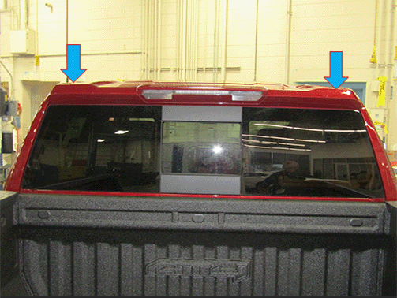  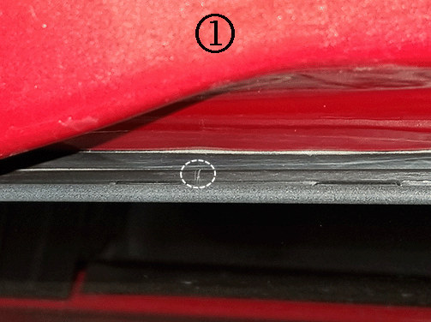  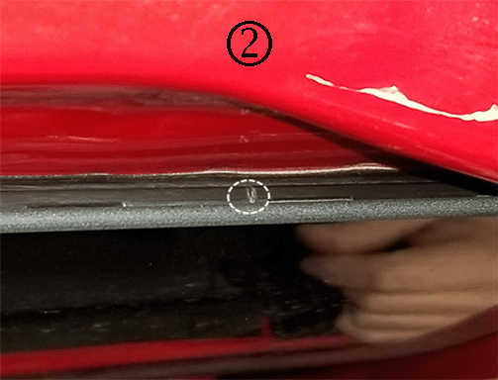  Note:  The cracks can be in the left and/or right side of the rear sliding window plastic upper rail glass guide which is covered by the roof rear spoiler. Examples of a left (1), then right side (2) visual crack (with the spoiler removed) are shown in the graphics above.  The cause of the condition may be cracking in the rear sliding window plastic upper rail glass guide. The plastic upper rail glass guide may develop small fractures/cracking which allows water to pass through on the glass side of the urethane that attaches to the vehicle body.
Correction | Important:  When verifying this condition, ensure that the water leak path is due to cracks in the rear sliding window plastic upper rail glass guide, and NOT a leak in the primary urethane seal, between the window and the body; or from the spoiler attachments to the truck cab which are in the same area. Please indicate power sliding rear window crack in warranty claim verbiage.  A leak in the primary urethane seal should be addressed by removing and resealing the window, using the standard service procedure from SI.  R & R the roof rear spoiler and apply seam sealer to the rear sliding window top encapsulate, following the steps in the Service Procedure below.
Service Procedure
- 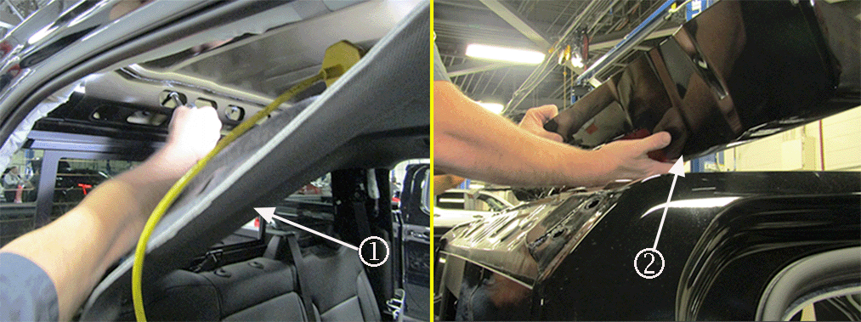
- Lower the rear portion of the headliner (1) and remove the roof rear spoiler (2). Refer to Roof Rear Spoiler Replacement, in SI.
- 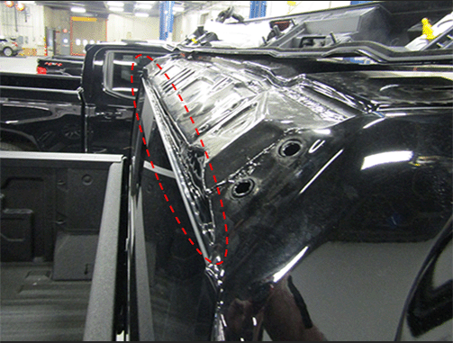
- Clean and inspect the full length of the cavity above the body to window urethane:

  - 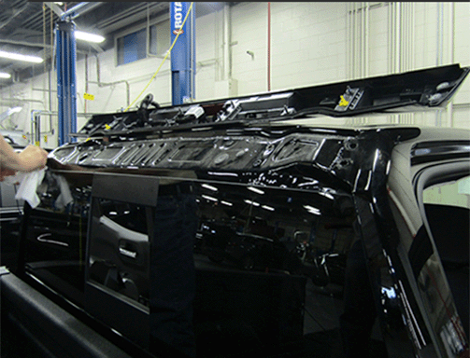
  - First using shop cloths and glass cleaner, or suitable equivalent, clean all grime, debris and water from the cavity.
  - 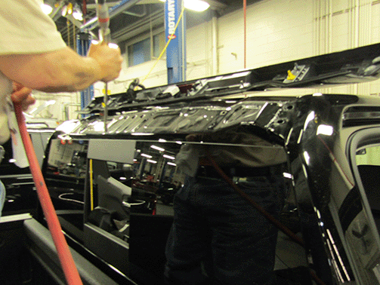
  - Then, using compressed air, blow away any excess moisture and allow the area to dry thoroughly.
- 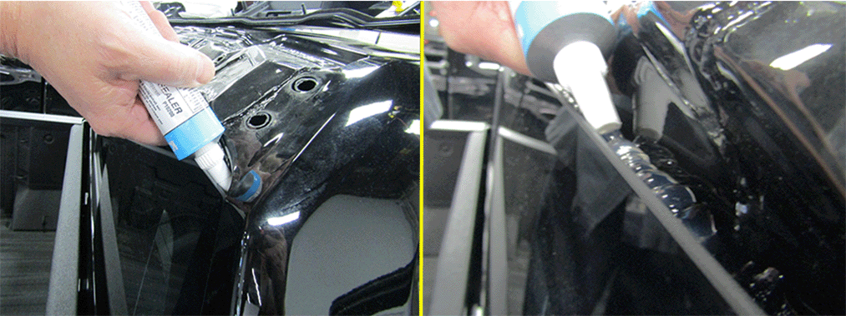
- Important:
Cut the applicator tip to a larger opening and use care to avoid getting the sealer on the upper/visible surfaces of the glass.
- Apply a generous bead of Kent® High-Tech Seam Sealer Clear P10200, or equivalent, across the complete length of the urethane/encapsulate. Allow the sealer to flow to a uniform thickness across the complete top of the window.
- 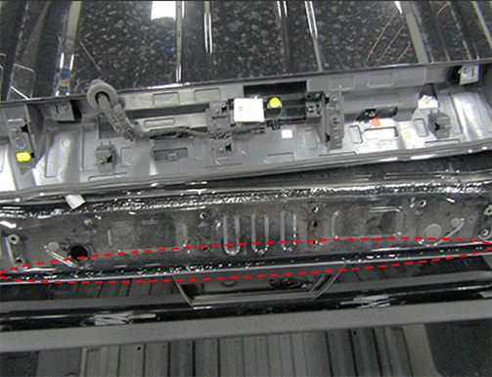
- Note:
The graphic above is a top view of the sliding window, while standing in the bed of the truck.
- Allow a short time for the sealer to develop a skim coat, then reinstall the spoiler and headliner. Refer to Roof Rear Spoiler Replacement, in SI.
- Allow at least 24 hours before running the truck through any car wash.
Parts Information
Causal Part | Description | Part Number | Material Allowance
N/A | Kent® High-Tech Seam Sealer Clear* | P10200 | $12.25 (U.S.)  $18.39 (Canada)
* We believe this source and their products to be reliable. There may be additional manufacturers of such products/materials. General Motors does not endorse, indicate any preference for, or assume any responsibility for the products or material from this firm or for any such items that may be available from other sources.
Warranty Information
For vehicles repaired under the Bumper-to-Bumper coverage (Canada Base Warranty coverage), use the following labor operation. Reference the Applicable Warranties section of Investigate Vehicle History (IVH) for coverage information.
Labor Operation | Description | Labor Time
2081088* | R & R Roof Rear Spoiler, Apply Seam Sealer to Rear Sliding Window | 1.5 hr
*This is a unique Labor Operation for Bulletin use only.
Version | 3
Modified | Released January 03, 2019  Revised February 01, 2019 – Added Important to Correction to Verify Failure.  Revised March 22, 2019 – Added Breakpoint and Revised Correction Important.
Sitemap | Terms & Conditions | Privacy Policy
Provided By Par-Tech, Inc.

