Front Fog Lamp Package Installation (Instruction ID: 84125495)
Installation Instructions Part Number
84152495
Procedure
Chevrolet and GMC
- Disconnect the negative battery cable. Refer to Vehicle Service Manual.
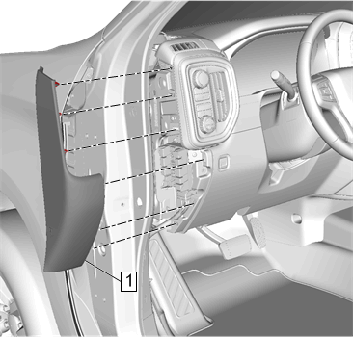
- Using a flat bladed trim tool, disengage the retainers and remove the driver side instrument panel outer trim panel (1).
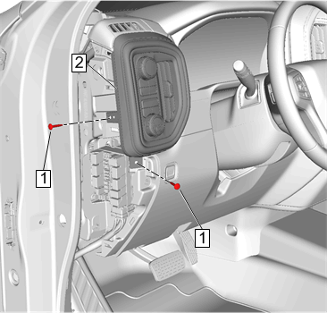
- Remove and retain the fasteners (1) securing the lamp switch bezel (2).
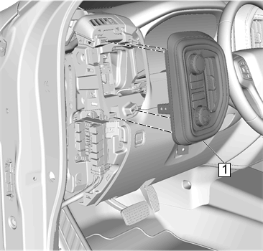
- Using a flat bladed trim tool, disengage the retainers and remove the lamp switch bezel (1) from the instrument panel. Disconnect the electrical connectors.
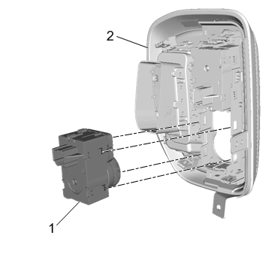
- Disengage the retaining tabs and remove lower switch (1) from the lamp switch bezel (2).
- Install supplied switch (1) in kit to the lamp switch bezel (2) engaging the retaining tabs.
- Connect the electrical connectors and reinstall the lamp switch bezel (1) to the instrument panel engaging the retainers.
Caution: Use the correct fastener in the correct location. Replacement fasteners must be the correct part number for that application. Fasteners requiring replacement or fasteners requiring the use of thread locking compound or sealant are identified in the service procedure. Do not use paints, lubricants, or corrosion inhibitors on fasteners or fastener joint surfaces unless specified. These coatings affect fastener torque and joint clamping force and may damage the fastener. Use the correct tightening sequence and specifications when installing fasteners in order to avoid damage to parts and systems.
- Reinstall the fasteners (1) securing the lamp switch bezel (2).

- Reinstall the driver side instrument panel outer trim panel (1) to the instrument panel engaging the retainers.
- Locate the BCM under the lower instrument panel on the driver’s side of the vehicle. Locate BCM connector (X5 Brown) cavity 10, circuit 1317 (BN/WH). It is giveaway on certain trim levels. If circuit is present in cavity 10, disregard steps 11 through 14, and 23 along with the single wire jumper that will not be needed. If circuit is not present, proceed to step 11.
- Lay the supplied wiring harness on the ground in front of the vehicle to get an idea how it is installed to vehicle.
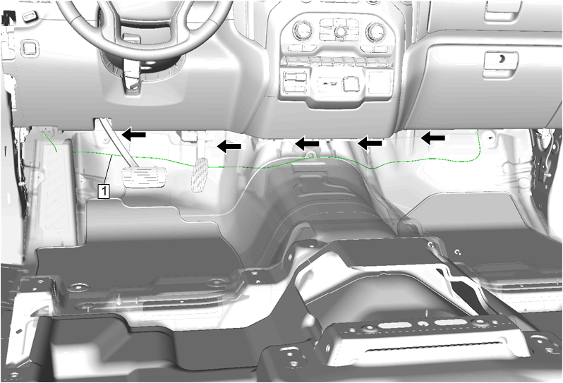

- Route the jumper harness (1) underneath the I/P structure towards the driver side . Secure jumper harness with provided tie straps as necessary.

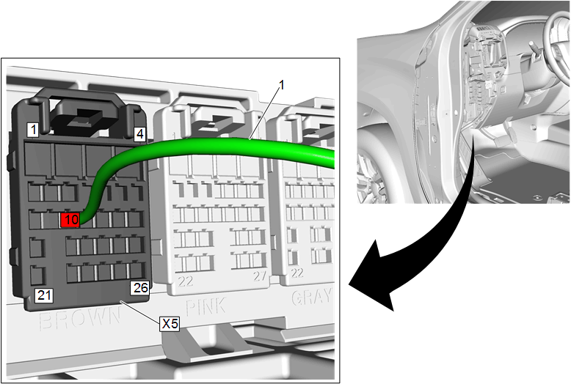
- Insert the lone single terminal on jumper harness (1) into BCM connector X5 Brown, cavity 10.
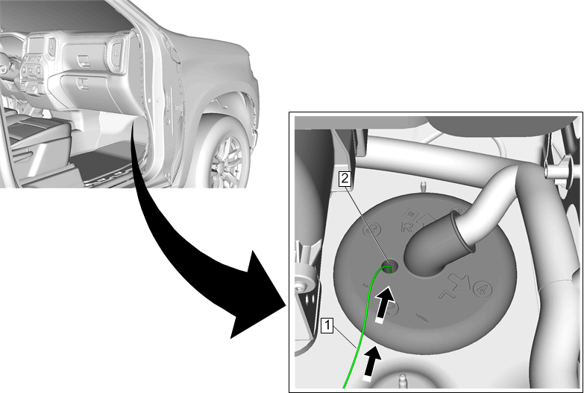
- On the passenger side of vehicle behind glove compartment, route the jumper harness (1) from the engine compartment through the grommet (2).
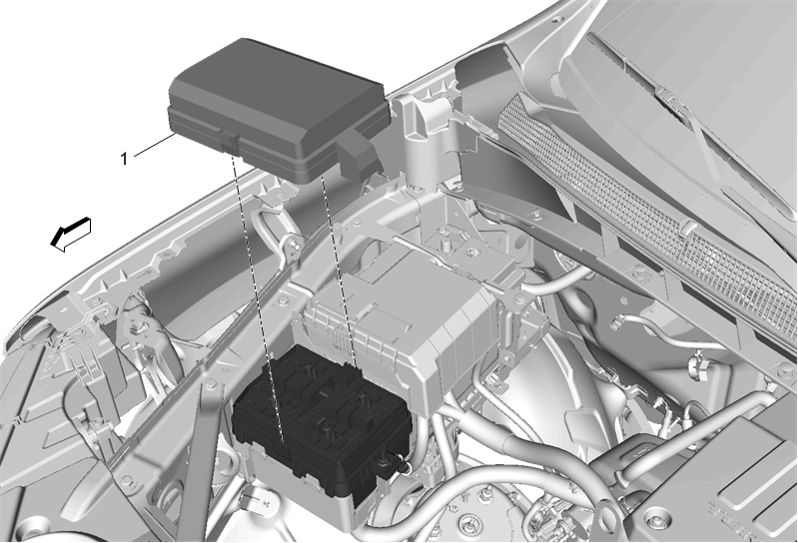
- Disengage the retaining tabs and remove the UEC cover (1) from the top of the UEC.
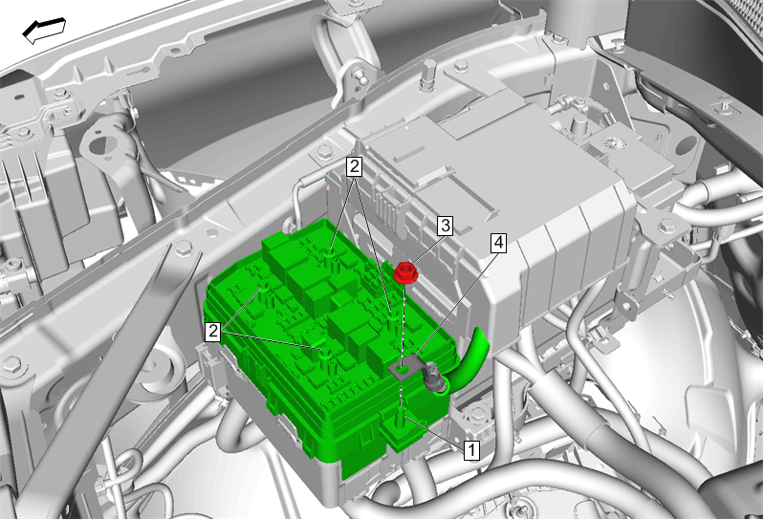
- Remove the nut (3) and terminal ring (4) from the UEC terminal post (1).
- Loosen the four bolts (2) on the top of UEC.
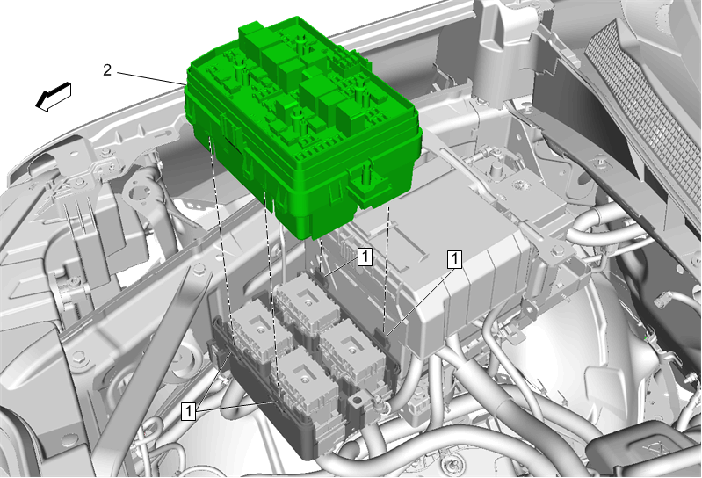

- Disengage the retaining tabs (1), pull up and remove the UEC (2) from its base.
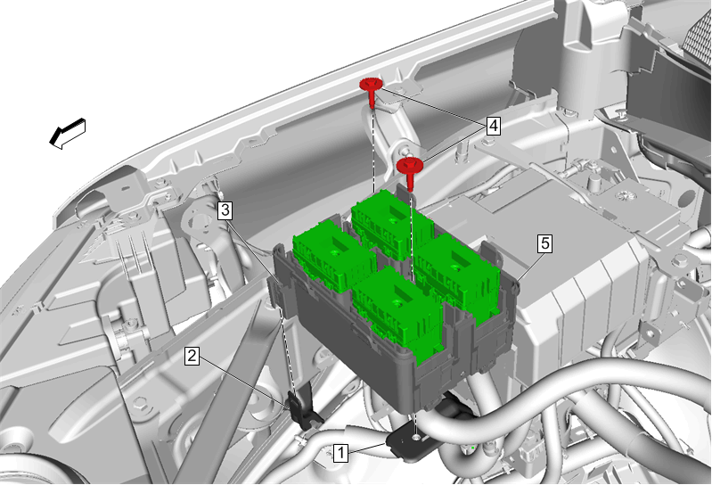
- Remove the fasteners (4) from the UEC base (5).
- Disengage retaining tab (3) from side bracket (2).
- Lift up and remove UEC base from brackets (1), (2).
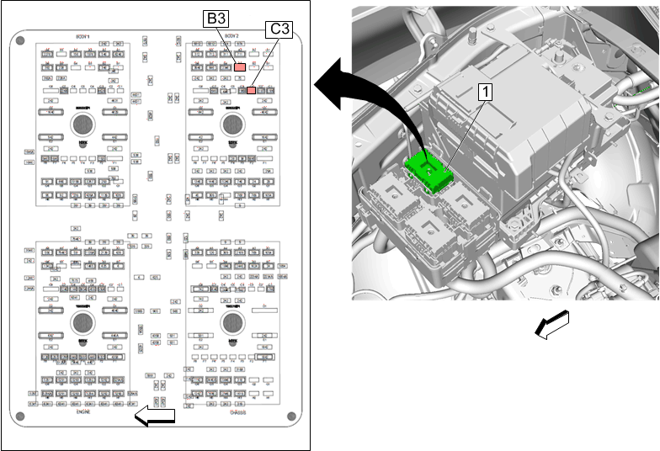
- Locate body 2 connector (1) in the UEC and remove body 2 connector (1) from clip to access the wire side of connector. Refer to Delphi Connector in Vehicle Service Manual.
- Locate Cavity (C3) on the Body 2 connector (1) in the UEC and insert the lone terminal from the BCM jumper harness into the cavity (C3).
- Locate the other jumper harness provided in kit and locate the lone terminal wire.
- Locate Cavity (B3) on the Body 2 connector (1) in the UEC. If there is a circuit present in this cavity, remove the wire and seal the terminal. Then insert the lone terminal from the jumper harness into the UEC connector, cavity B3.
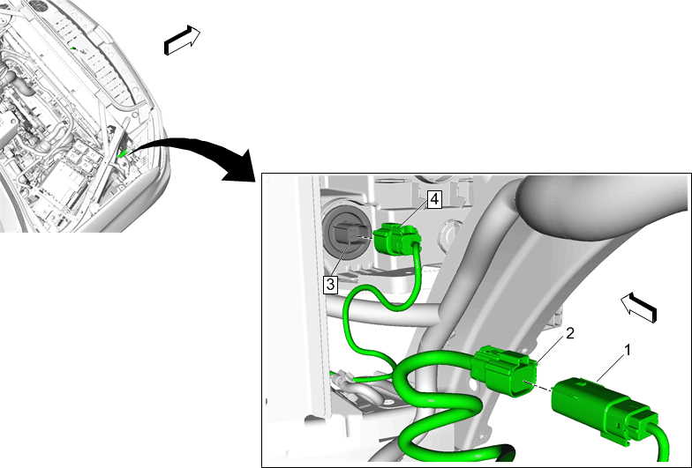
- Locate the connector (2) on the RH side headlamp (3) and disconnect.
- Locate the similar connector (4) on the jumper harness and connect to RH side headlamp (3).
- Insert the other connector (1) on the jumper harness into the previously removed RH headlamp connector (2).
- Re-assemble the UEC making sure it is fully seated before securing the fasteners.
- Raise and suitably support the vehicle. Refer to Vehicle Service Manual.
Chevrolet Fog Lamp Procedure
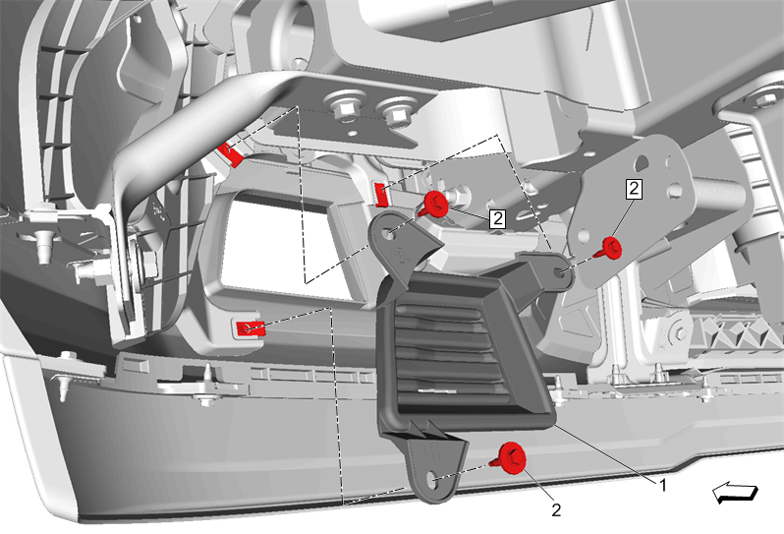
- Remove the fasteners (2) and the fog lamp covers (1) LH and RH.
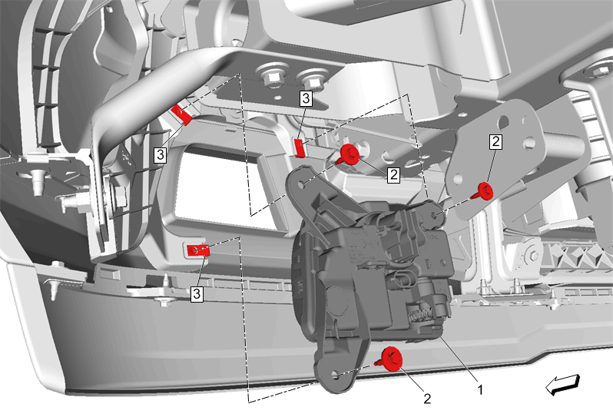
- Install the U-nuts (3) and fog lamp (1) LH and RH to the fog lamp opening.
- Secure the fog lamp LH and RH with the fasteners (2). Tighten the fasteners.
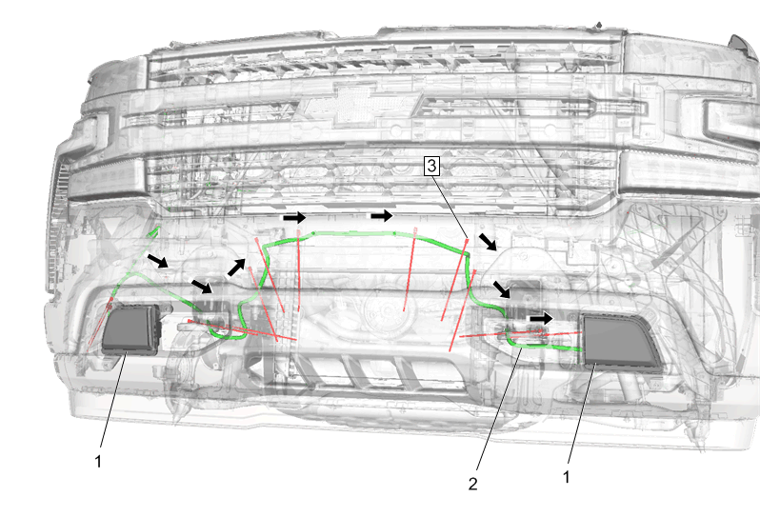
- Route the jumper harness (2) as shown behind the front bumper to the fog lamps (1). Secure the jumper harness with the supplied tie straps (3) as necessary.
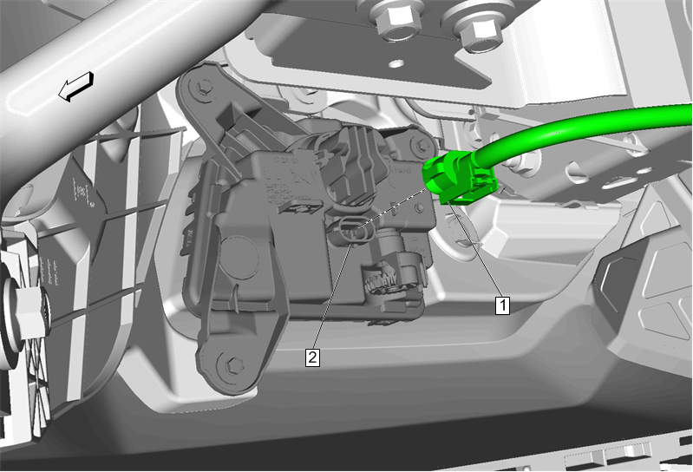
- Connect the jumper harness (1) to the fog lamp (2) LH and RH.
- Lower the vehicle.
- Connect the negative battery cable. Refer to Vehicle Service Manual.
- With the support of the Tech Line, download the new BCM calibration to support the new fog lamp feature.
Note: The installation of this accessory fog lamp kit requires programming and configuring of the vehicle. This is done with a Service Programming System (SPS-TIS2WEB). Call TCSC to obtain a VCI number. United States 1-888-337-1010 Canada (English) 1-800-828-6860 Canada (French) 1-800-503-3222. The Techline Customer Support Center will provide programming instructions and changes to the vehicles calibration settings. You must provide the vehicle identification number (VIN) of the vehicle to be programmed and the authorization code when calling TCSC.
- Using the Scan Tool with a MDI, and (SPS-TIS2WEB), update the body control module (BCM) calibration file .
- Test the fog lamps operation.
- Reinstall any previously removed components.
- Aim the fog lamps if necessary. Refer to Vehicle Service Manual.

