CREADER INSTRUCTIONS
To recap, I bought the "GM specific" reader in the link I posted above. Before I connected it to the truck, I powered it on with the USB cable, connected to wifi and did the initial software update and downloaded the GM specific software that was included with the purchase.

Connect it to the OBDII port. I then turned the ignition on, truck off (mine is an SLT with push button start. Push and hold the start button without pressing the brake pedal until things 'turn on'). Then to get to the tire pressure warning adjustment:

1. Diagnostics
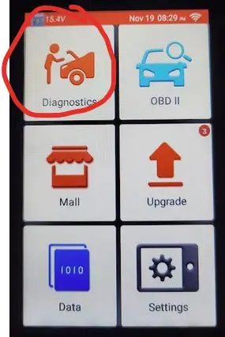

2. GM


3. OK
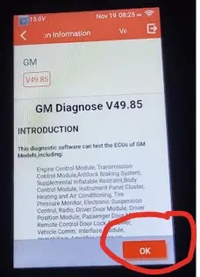
4. Automatically search, and 5. Yes
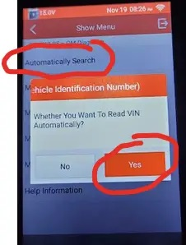
6. If not already 'on', follow the Ignition on, engine off instruction. Otherwise hit OK.
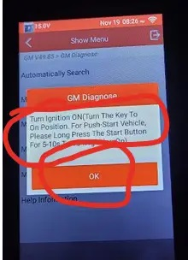

7. Common functions
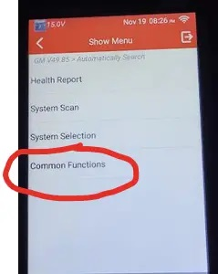
8. The reader will begin to scan the various modules of the truck. You'll get a series of questions about what modules are installed. If you get it wrong you won't break anything. You are not writing any info at this point. If I didn't know the right answer I just picked the first option. Here is what I used: 0301, MYD, 0501, SRW, not equipped, U1D, UHS, not equipped, IOT, 0627, AUN, UD5,

10. Scroll down to select tire type reset

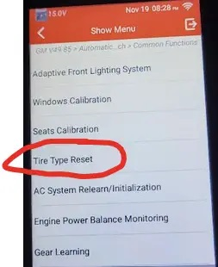

11. Select tire type/pressure selection
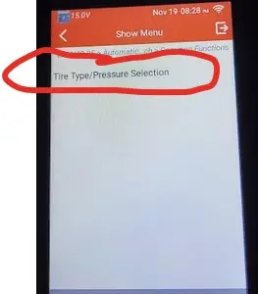
12. You'll then get two screens with a short story about passenger car tires and light trick tires. Just hit ok twice

13. Touch the current tire pressure target number (413 in my case). It will ask you to enter a new value in kPa for the front. Touch the blank spot for the 'Expect Value' to enter the new value. Follow the prompts to save/write the new value. Just a heads up, if you enter the same value as what is currently showing, you will get an "out of range error".

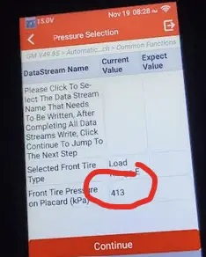

14. Continue to update the rear. Follow the prompts to save/write the new value.

Make any/all changes at your own risk. You are responsible for your actions and any changes made using the reader. This story was based on my experience only. Your experience may vary. etc etc etc.

