C1 Blue PCM Pinouts for 2001 Chevy Silverado
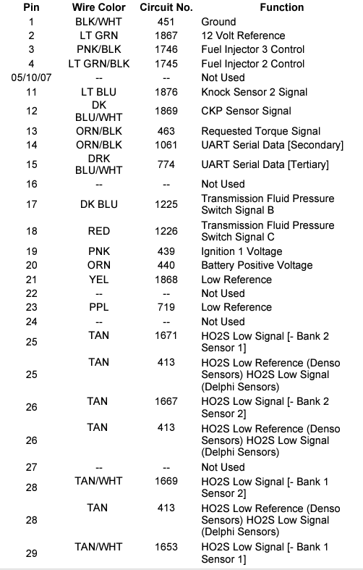
C1 Blue PCM Pinouts for 2001 Chevy Silverado
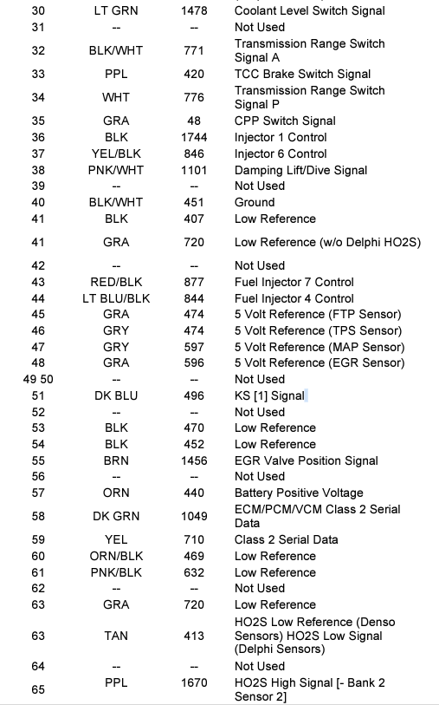
C1 Blue PCM Pinouts for 2001 Chevy Silverado
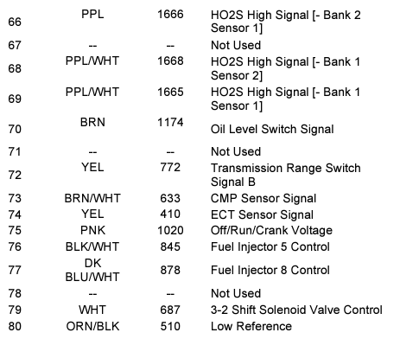

C2 Red PCM Pinouts for 2001 Chevy Silverado
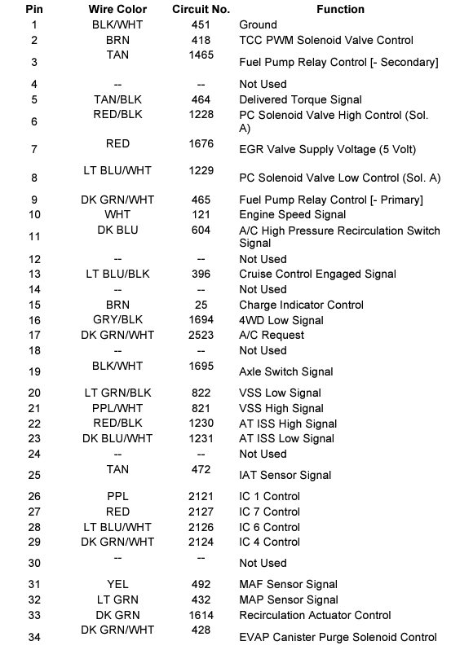

C2 Red PCM Pinouts for 2001 Chevy Silverado
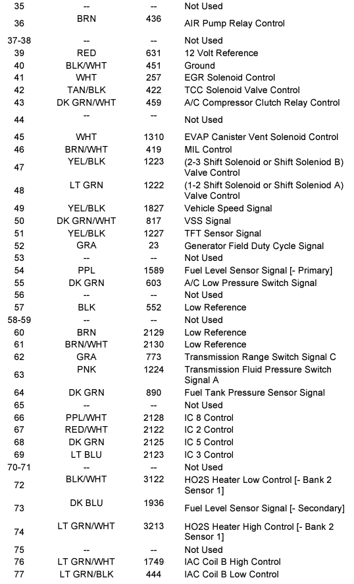

C2 Red PCM Pinouts for 2001 Chevy Silverado
